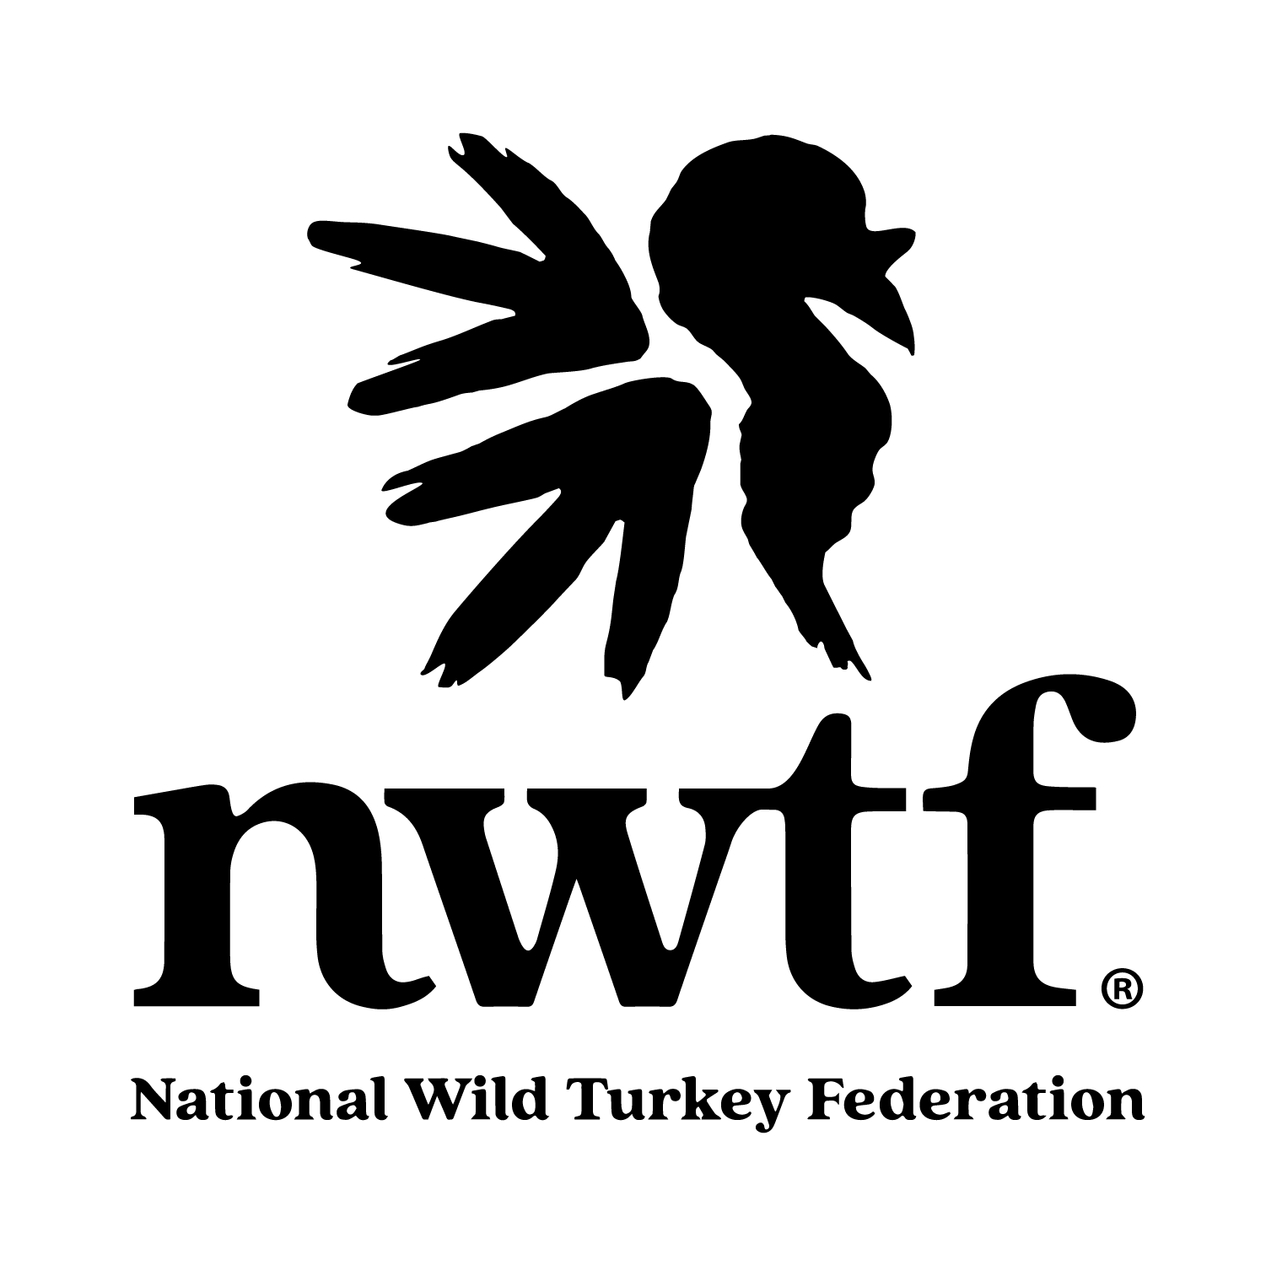 | NATIONAL WILD TURKEY FEDERATION |  2026 Research Grant Proposal Form

Funding Request Summary
Amount Requested: | 2026: $ | 2027: $ | 2028: $

Section 1: Project Information

State: |  | Title of Project:
Principal Investigator: |  | Title:
Affiliation: |  | Phone:
Email:

NWTF Research Priority or Priorities Addressed (see announcement):

Objectives — State clearly and concisely the objectives of this project:

Section 2: Investigators & Cooperators
Co-Investigator 1
Name: |  | Title:
Affiliation: |  | Role:
Address:
Phone: |  | Email:
Co-Investigator 2
Name: |  | Title:
Affiliation: |  | Role:
Address:
Phone: |  | Email:
Co-Investigator 3
Name: |  | Title:
Affiliation: |  | Role:
Address:
Phone: |  | Email:
Cooperators (government agencies, NGOs, or other partner organizations)
Cooperator 1
Name: |  | Title:
Affiliation: |  | Role:
Address:
Phone: |  | Email:
Cooperator 2
Name: |  | Title:
Affiliation: |  | Role:
Address:
Phone: |  | Email:
Cooperator 3
Name: |  | Title:
Affiliation: |  | Role:
Address:
Phone: |  | Email:

NWTF District Biologist, NWTF State Chapter & State Agency Coordination — Describe coordination and confirm all required agency approvals and permits have been secured (i.e., for trapping wild turkeys or other wildlife):

Section 3: Project Description

What are the expected benefits of this research (i.e. turkey resource, wildlife managers, hunters, the NWTF, etc., and how will results inform management decisions)?

Description of Study Area (attach shapefiles or maps if possible):

If applicable, please list NWTF Landscape-Scale Initiatives (https://www.nwtf.org/content-hub/from-big-six-to-a-bigger-impact) in which the project will occur or support:

Methods — Provide detailed, cited methodology describing how objectives will be achieved and how data will be analyzed:

Literature Cited:

Section 4: Project Timeline

Activity / Year | J | F | M | A | M | J | J | A | S | O | N | D

Section 5: Project Budget
Contributions below represent total project support from all partners. Required 3:1 leverage ratio. Only funds committed during the project period are eligible to count toward the match. State Chapter or local NWTF funds do not count toward the required match.
Year: 2026 Percent funded by NWTF: ______
Cooperator | Personnel Services | Equipment & Supplies | Operating Expenses | Data Fees | Publication Costs | TOTAL
TOTAL

Year: 2027 Percent funded by NWTF: ______
Cooperator | Personnel Services | Equipment & Supplies | Operating Expenses | Data Fees | Publication Costs | TOTAL
TOTAL

Year: 2028 Percent funded by NWTF: ______
Cooperator | Personnel Services | Equipment & Supplies | Operating Expenses | Data Fees | Publication Costs | TOTAL
TOTAL

Budget Detail — Request from NWTF:
Item | 2026 | 2027 | 2028 | Total
Travel
Salary
Equipment
Services
Publication Costs
Other
TOTAL

Section 6: Publications & Signatures
Three Most Significant Publications by PI or Co-PI:
1.
2.
3.

Principal Investigator Signature |  | Date
Co-Investigator Signature |  | Date

General Research Grant Reporting Procedure
As a condition of NWTF funding, all researchers are required to provide progress reports and other information using the following format, and are expected to be responsive to reasonable requests for additional information or materials (e.g., updates, highlights, photos) to support NWTF communications and outreach efforts:
Biannual Reports
• No more than 2 pages
• Progress since last report
• Significant problems encountered
• Report dates: April 1 and October 1
Annual Reports
• Summarize biannual reports
• Show preliminary results
• Show accounting of NWTF funding
• Summarize how findings inform management decisions
• Include completed deliverables (publications, reports, theses, presentations)
Final Report
• Final accounting of NWTF funding
• Published form of the project report
• Synopsis suitable for Turkey Call magazine or NWTF website
• Summarize how findings inform management decisions
• Include all completed project deliverables
All reports must be submitted to: Patrick Wightman, PhD (pwightman@nwtf.net)

Funding Disclaimer
NWTF limits support to direct costs only and does not allow NWTF funding to pay for indirect expenses. "Direct costs" are expenses required for and trackable to the research project. "Indirect costs" cannot be tracked directly to the NWTF grant. If listing indirect expenses as match/leverage, please provide a fully executed NIRCA letter at time of project submission.
Please notify Patrick Wightman, PhD (pwightman@nwtf.net) if you require a disclaimer letter outlining our funding restrictions. Thank you for collaborating with NWTF!

